Getting the most out of your Port of Portland Vendor Profile

Have you updated your profile in the Port of Portland’s new electronic bidding portal yet?

Whether you have or haven’t, you will want to be sure you take advantage of all the fields of information you can provide to the Port. Your Vendor Profile is your introduction to all Port staff; it provides a wealth of information that lets us know more about you and your firm’s capabilities.

Aside from the normal, everyday pieces of information you are used to providing in a vendor registration, there are pages where you can:

- Provide additional addresses (“Order From” and “Remit to”)
- Tell us about your licenses and certifications (women-owned business, minority-owned business, construction contractor license, etc.)
- Provide information on Company size, years in business, and other useful information

However, the most important tab in your Vendor Profile is the “Category/Description” tab. Here is where you tell us, in your own words, how you can be of benefit to the Port of Portland.
You also select all of the Commodity Codes that might apply to your business. The Port now uses the National Institute of Governmental Purchasing (NIGP) Commodity Code system to identify business types. These codes will determine if you will be notified of an upcoming business opportunity.

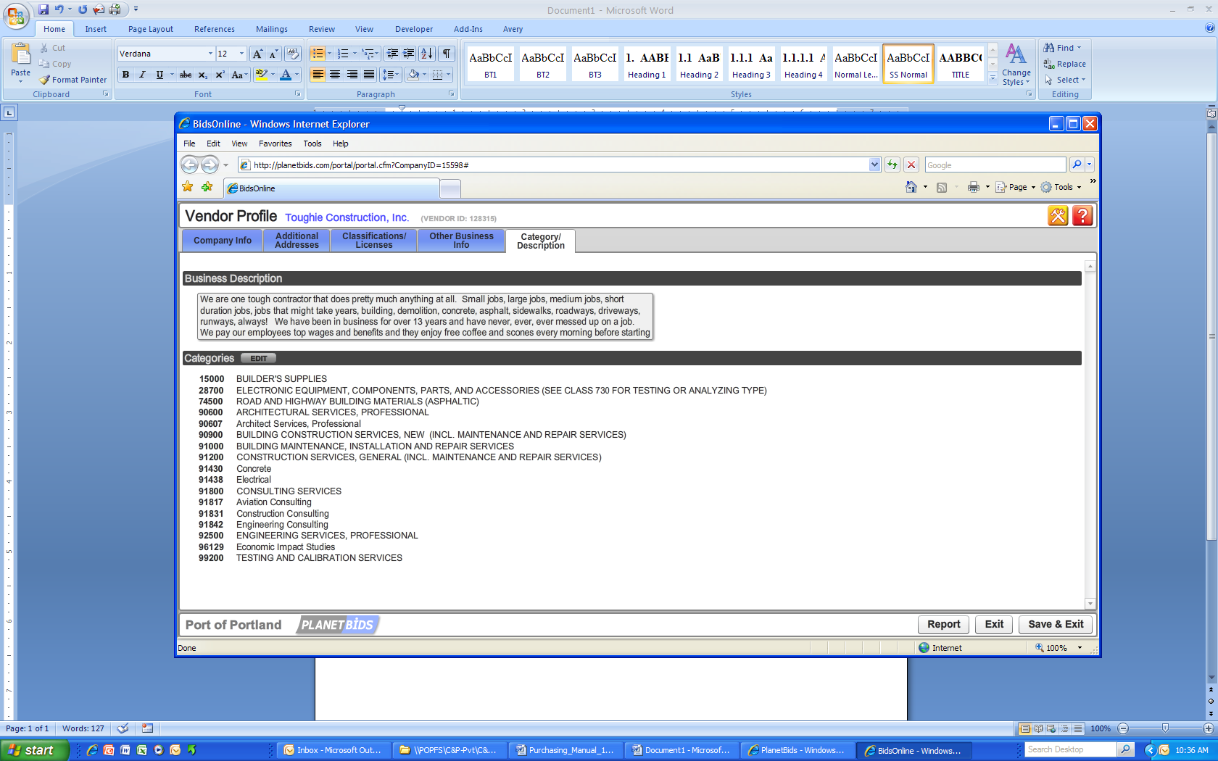
Figure 1- Vendor Profile Category/Description Tab

Carefully and accurately describe your business capabilities, the types of products you offer, and any other information you may want to provide in your business description. Then, be sure to select both general category and specific category NIGP Commodity Codes. Spend the few minutes it takes to search the codes for each commodity code that describes your business type. This will help to ensure you don’t get missed when a new opportunity is published.
The Port’s previous vendor portal broadcast opportunities over a broad scale of vendor types, i.e., construction, general services, personal services, and goods and equipment. As a result, you were often sent notices of opportunities that did not meet your specific area of expertise. Our new system broadcasts to specific commodity codes only. We endeavor to choose all applicable codes for each solicitation. Ensuring you have all the appropriate codes identified in your profile will ensure you receive quality notices, not just “spam”.
We are excited about our next generation Vendor Portal and hope you find it easy to use and informative. Keeping your Vendor Profile up to date is your responsibility. Please periodically review your Vendor Profile information to ensure it is accurate.
If you have any vendor registration related questions, click on the 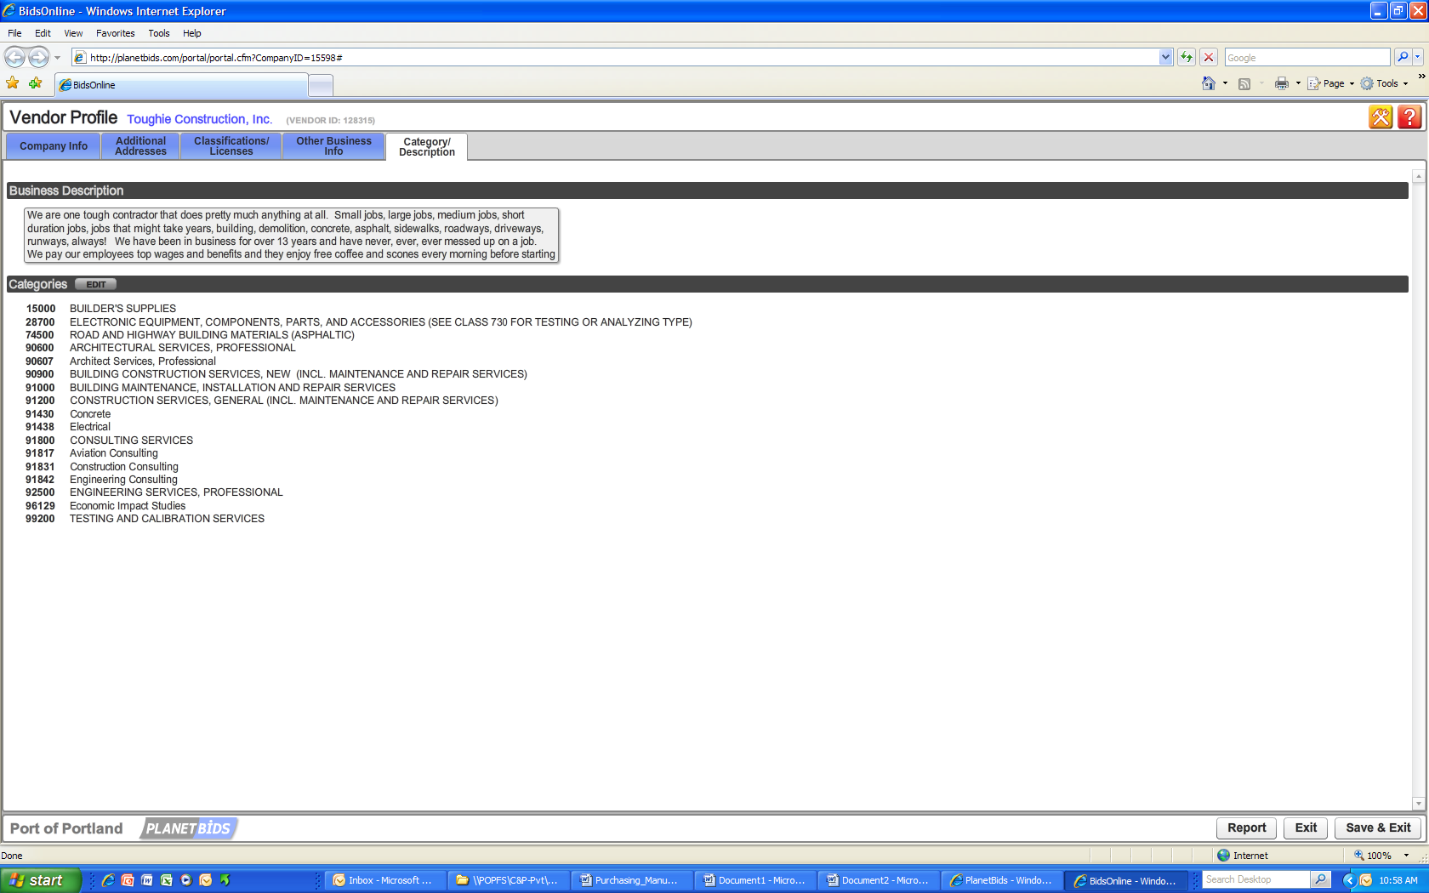 button in the top right-hand corner of your Vendor Profile for answers to frequently asked questions or direct contact to PlanetBids Support.

THANK YOU FOR YOUR INTEREST IN DOING BUSINESS
WITH THE PORT OF PORTLAND.

